Image Stitching with OpenCV

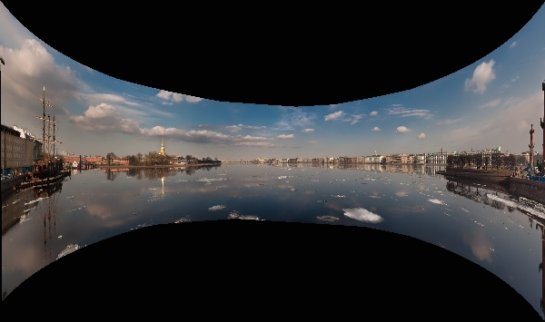

Have you ever tried to capture a beautiful landscape, only to find that your camera can’t fit it all in the frame? That’s where panoramic images come in. They allow you to capture the entire horizontal view in a single shot. The process behind these images is just as fascinating as the final picture.
The panoramic image you took is actually a composite of multiple overlapping images. This technique is called IMAGE STITCHING. This blog explains the step-by-step workflow of Image Stitching.

What is Image Stitching?
Image Stitching is a technique in Computer Vision that stitches multiple overlapping images seamlessly to create a wide and high-resolution view. This technique involves the identification of points and aligning them smoothly.

Key Concepts in Image Stitching
- Collecting Input Images: The process begins with gathering overlapping images. These images are usually taken with the same exposure and camera settings to avoid confusion and faulty results.
- Feature Detection: After capturing images, we need to extract the useful information, like corners, edges, and patterns in the image.
- Feature Matching: We need to match common features (Overlapping points) in those images to find the similarities between them.
- Homography Estimation: Calculate the homographic matrix to understand the transformation needed for perfect alignment of the images.
- Image Warping and blending: Warp the image so that it aligns with the next image, and after that, blend the images smoothly to get a panoramic output.
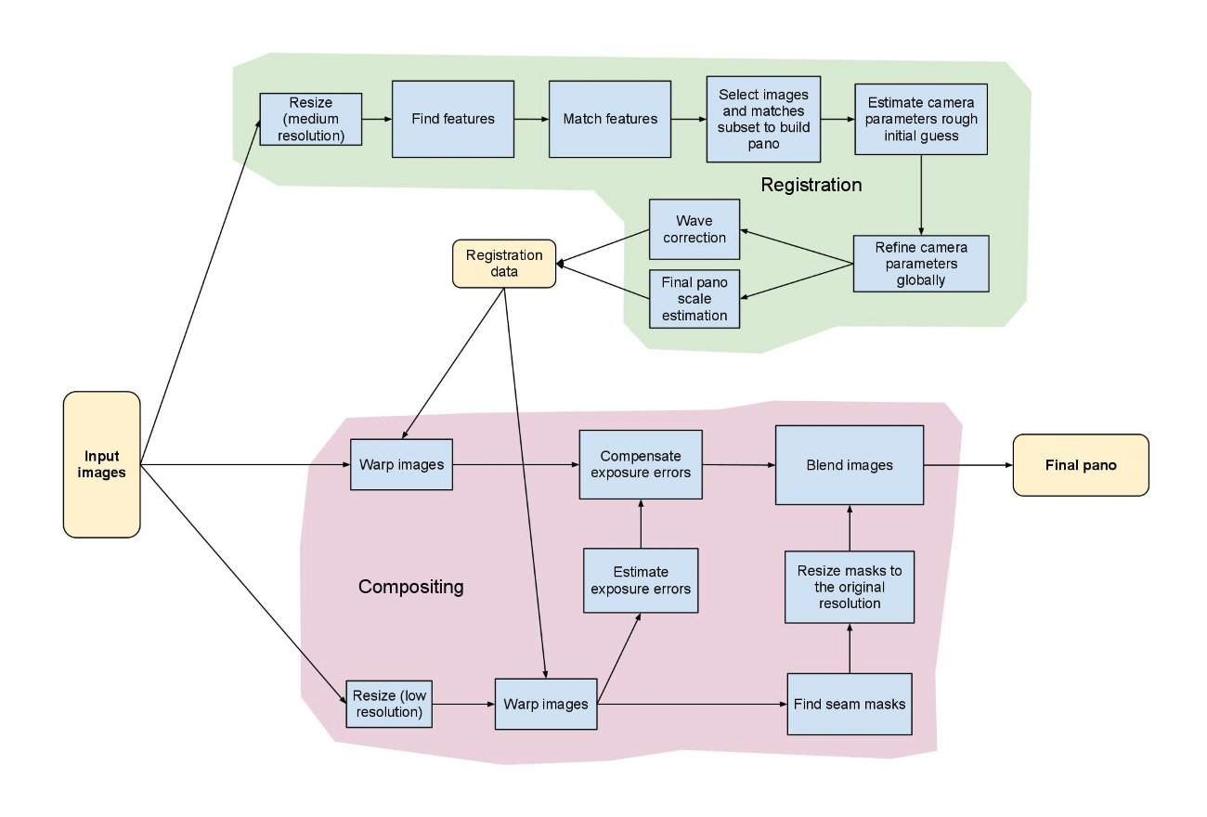

Workflow

1. Load Input Images
Take at least two images that have a common or overlapped area and load them in grayscale for better results.

2. Detect Features

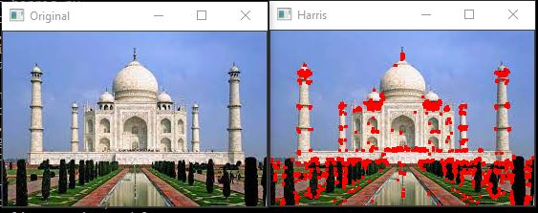
There are many algorithms available in OpenCV to detect features in an image, such as SIRF (Scale-Invariant Feature Transform) , SURF (Speed UP Robust Features), ORB (Oriented Fast and Rotated Brief), and many more. We have created an ORB feature detector with the help of cv2.ORB_create() function and through .detectAndCompute() function, we can find keypoints and descriptors in the images.
This process plays a crucial role in image stitching as it detects important keypoints between the images.

3. Matching Features
Now, after finding the common points, we match the descriptors of the images by comparing the common points of each image. For matching, we can use the BruteForce Matcher. It is a method in Computer Vision to match the keypoints in an image.

4. Homography Matrix
When we take overlapping images, they slightly differ in angles or position. So, to avoid misalignment of the images, we make a (3 x 3) Homography Matrix. But before that, it is suggested to filter out the matches through the RANSAC method to avoid noisy feature matches in the homography matrix. Now, to calculate the Homography matrix, we use .findHomography() function. It helps in the transformation of images by mapping points from one image to corresponding points in another image.

5. Warping and Blending of Images
After calculating the matrix, we can finally stitch the images together using cv2.warpImages(). It ensures the correct position of each image. After this , the images are blended to smooth out the edges for seamless stitching.

Result
When you proceed with the above-mentioned steps, the pictures are fused together, appearing like a single wide view shot. In a perfect world, there would be no noticeable seams, distortions, or color disparities at all. The end panorama shows much more of the surrounding area than the images that were originally taken.

Applications of Image Stitching
- Mobile Cameras (Panorama Mode)
- Virtual Reality (360° Views)
- Drone and Satellite Imaging
- Medical Imaging (Pathology, Microscopy)
- Document Scanning / Archiving
- Robotics & Autonomous Navigation
- Surveying and Mapping

Advantages
- Generates large-scale panoramic images with great detail.
- Dramatically enlarges the field of vision.
- Compatible with regular camera inputs.
- Applicable to various industries.
- Allows a scene to be viewed in a much bigger way.

Limitations
- Sufficient image overlap is necessary.
- Lighting variations could lead to seams being noticeable.
- Parallax mistakes happen when the camera position moves a lot.
- Scenes with very high texture or very low texture may compromise accuracy.

Conclusion
Image stitching is a computer vision technique that plays a significant role in overcoming the camera's field of view limits by creating a wide panorama from several images. Despite the fact that the whole process is made up of several steps, such as feature detection, matching, homography, warping, and blending, the major idea behind it is elegant and powerful. The range of applications of image stitching stretches from mobile photography to medical imaging and keeps on growing due to the progress of technology.

References
- https://www.geeksforgeeks.org/computer-vision/image-stitching-with-opencv/
- https://docs.opencv.org/3.4/d1/d46/group__stitching.html
- https://ieeexplore.ieee.org/abstract/document/6896208

